SonarQube installation

**Installation of SonarQube**

Following is instruction-set to get setup with SonarQube:

* Go <https://www.sonarqube.org/downloads/>-🡪click show all versions
* https://sonarsource.bintray.com/Distribution/sonarqube/sonarqube-5.2.zip
* Unzip the downloaded file
* Go to <install_directory>/bin folder. You would find different folders related with OS platforms. As I have 64 bit Win system, I further went inside “windows-x86-64″ folder.
* You shall find different shell scripts files. For my win platform, I found different *.bat file such as InstallNTService.bat, StartNTService.bat, StartSonar.bat etc.
* Copy the path of this folder which may look like S<install_director>/bin/Windows-x86-64 (in case of my laptop), and append it to “Path” environment variable.
* Open a command prompt, type “StartSonar” command and execute. This would start a web server at default port of 9000.
* Open a web browser and access the page, http://localhost:9000. You shall see the page such as that shown in the screenshot below. This means that you have been able to successfully start your SonarQube server. Job, well done! Lets move further to analyze Spring PetClinic Sample Application.

Step :

* 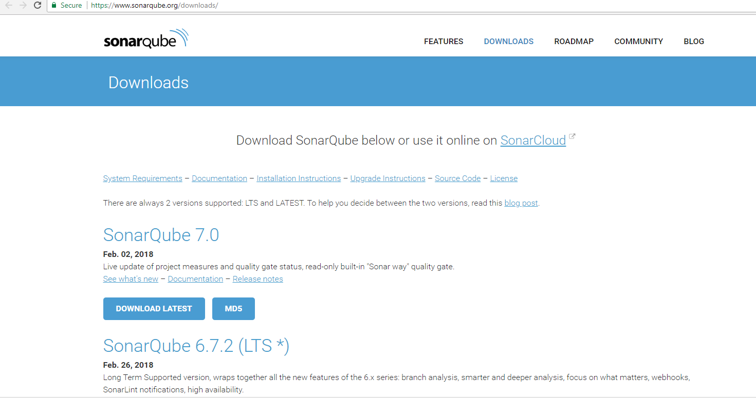

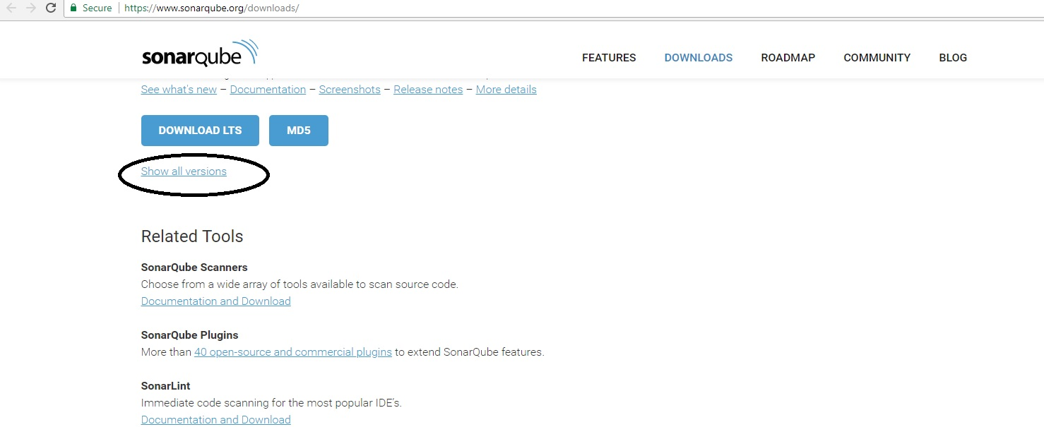

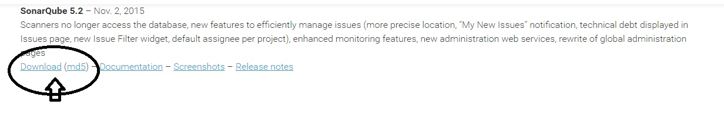

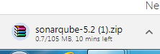



Step : Extract the sonarqube-5.2.zip

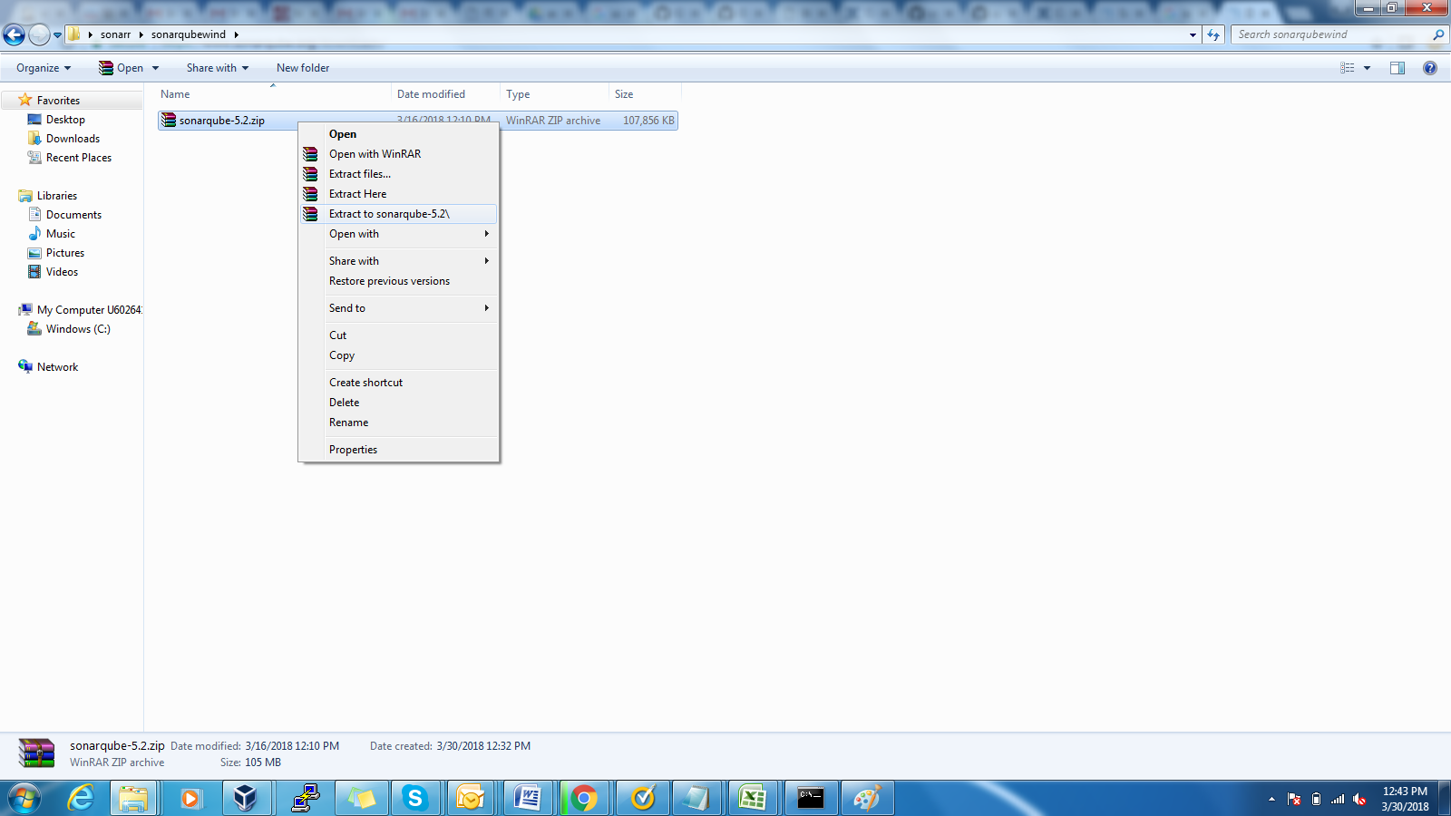

Step : After Extract zip file

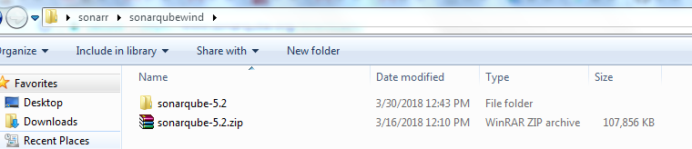

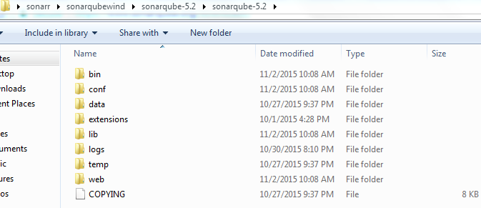

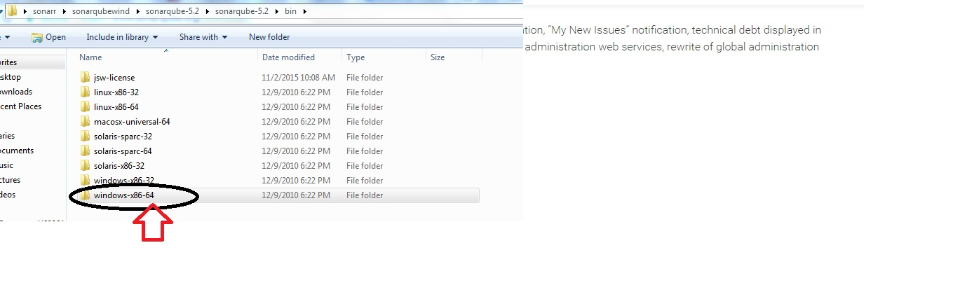

Step : Double click on 🡪StartSonar.bat file

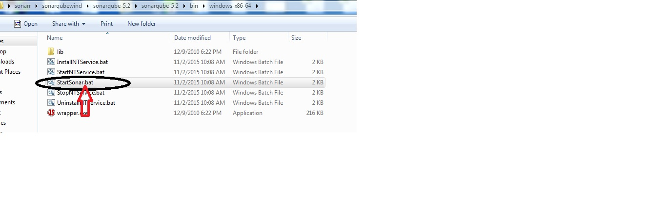

Step : once StartSonar.bat file we will get pop window like below it means sonar installation start

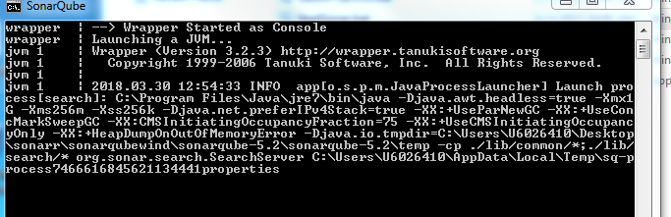

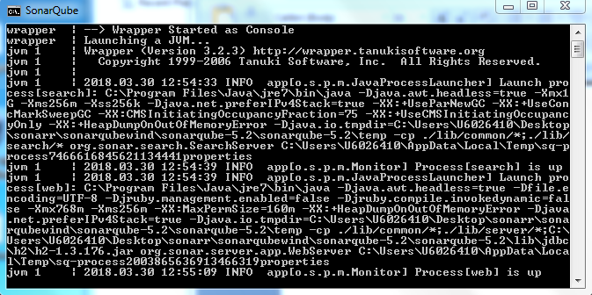

Step : after that login sonar local machine

Step : open browser type localhost:9000



Step : click on login

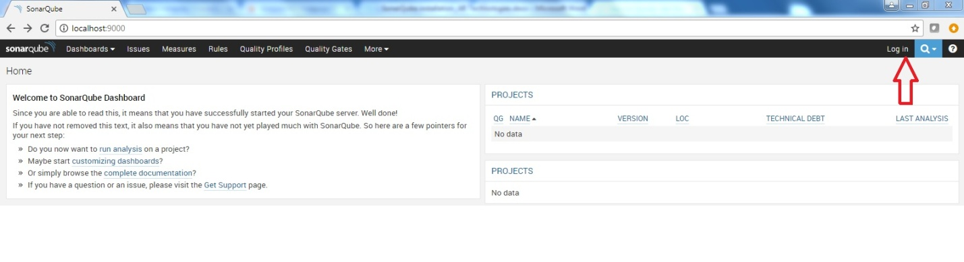

Step : give sonar login credentials below **username : admin password : admin**

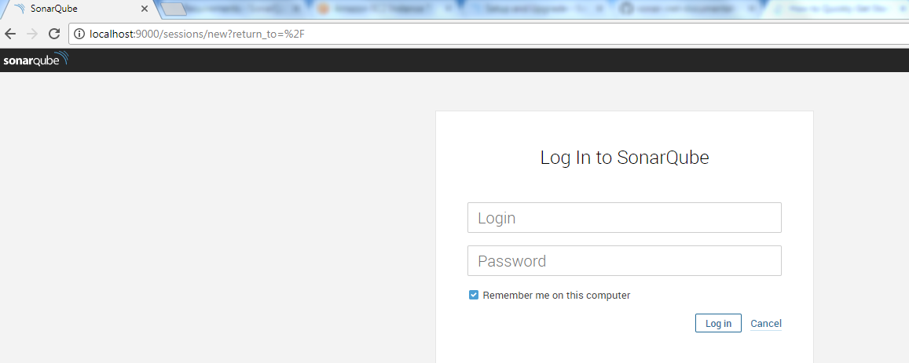

Step :

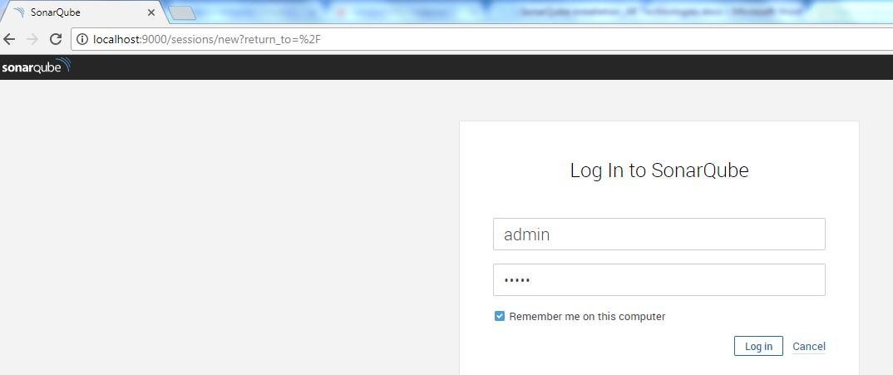

Step : after login sonar you will get sonar Dashboard like below

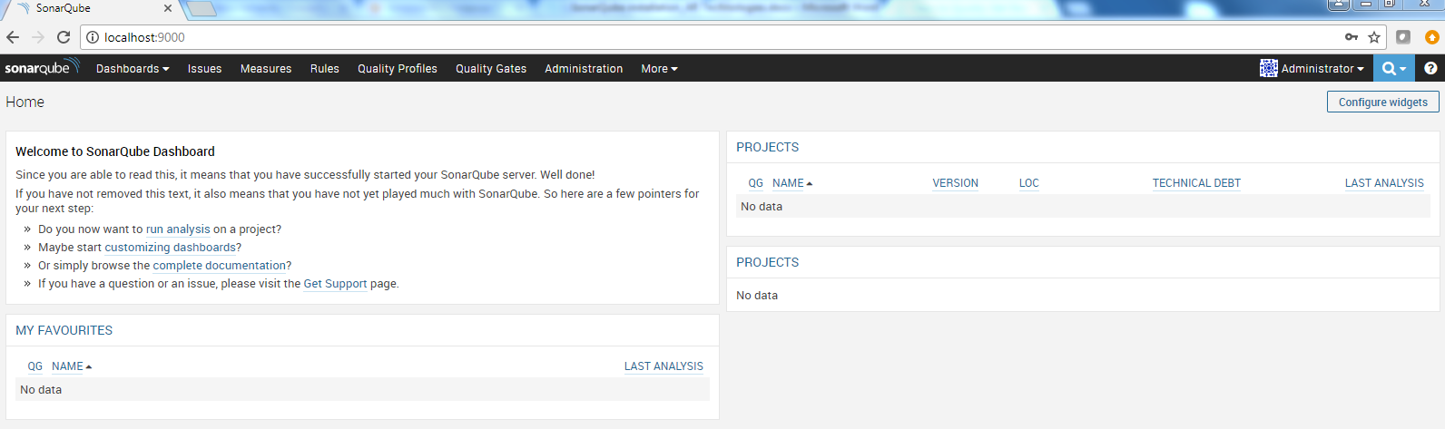

Step : Download Sonar runner form below link

Step : <http://repo1.maven.org/maven2/org/codehaus/sonar/runner/sonar-runner-dist/2.4/>

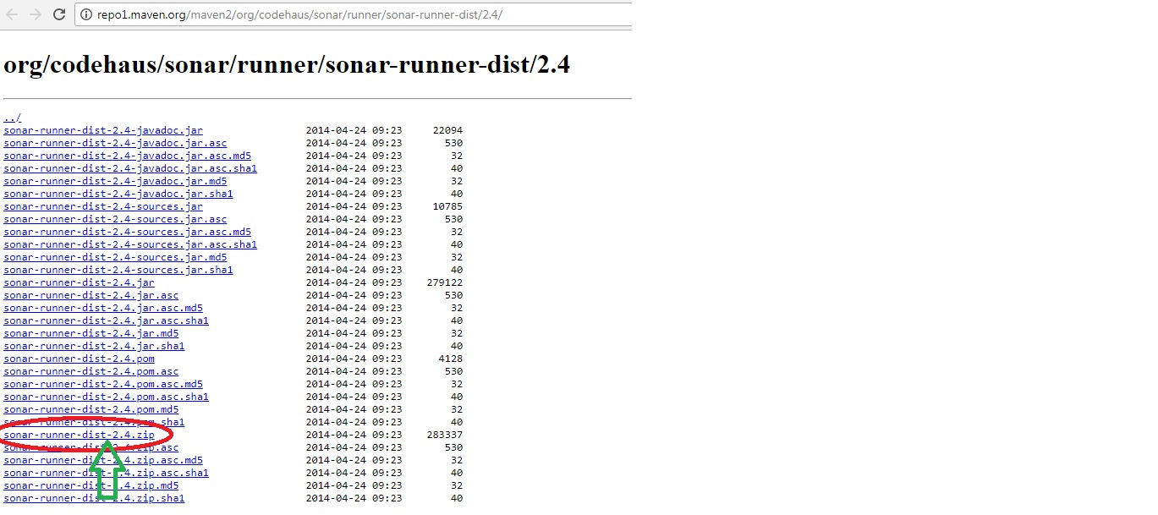

Step



Step:



Step :

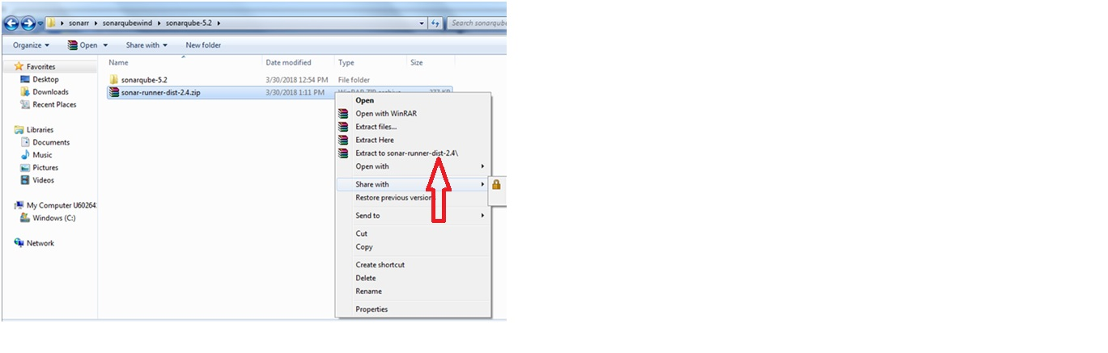

Step: Give Sonar Runner environment variable path.

Click on Pc🡪Properties🡪Advance System settings🡪Environment variables

Step :

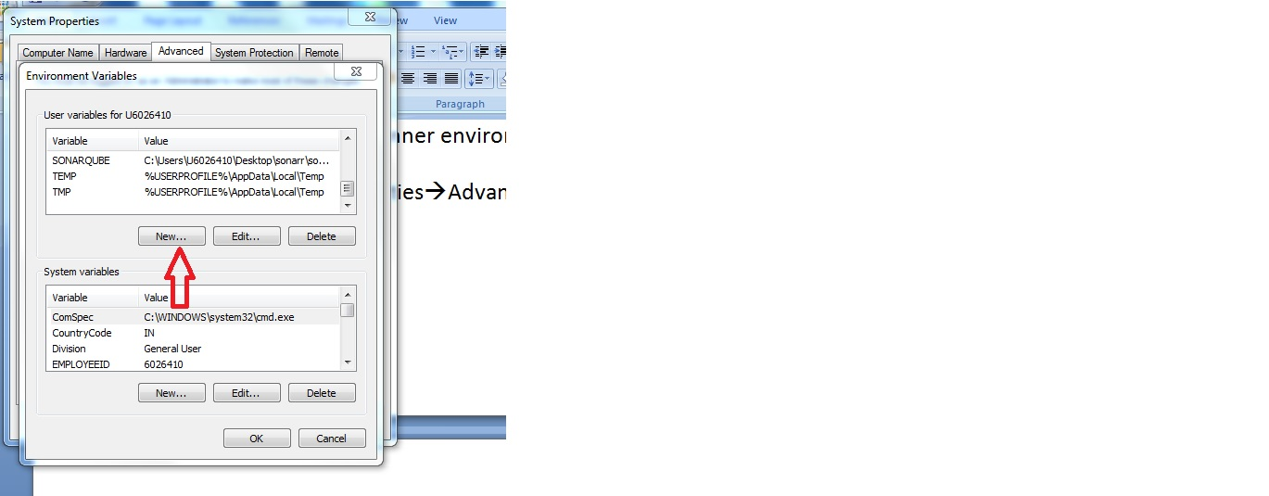

Step : SONAR_RUNNER_HOME

Step : C:\Users\U6026410\Desktop\sonarr\sonar-runner\sonar-runner-dist-2.4\sonar-runner-2.4\ (as per sonar runner path)

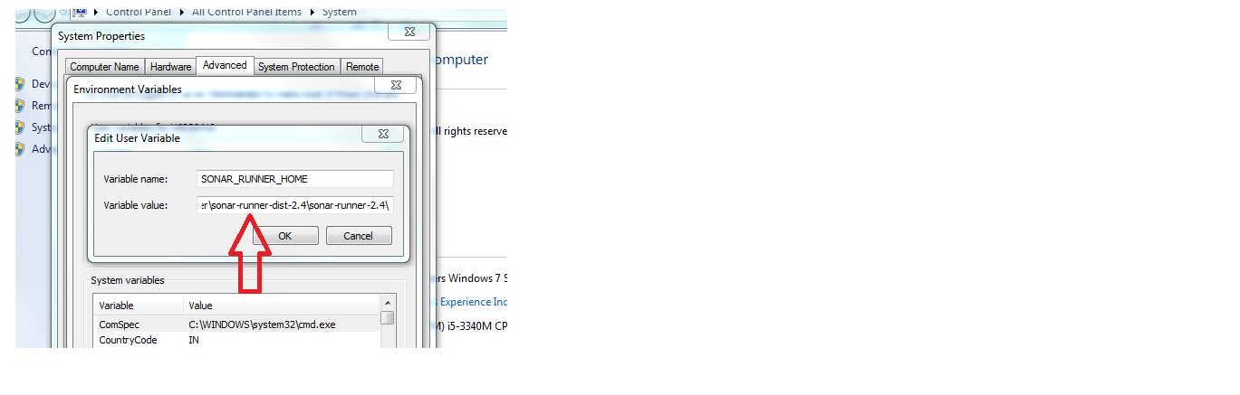

Step : go to github download maven and sonar code

Step : open browser go that link : <https://github.com/kkrdevops/sonar-test>

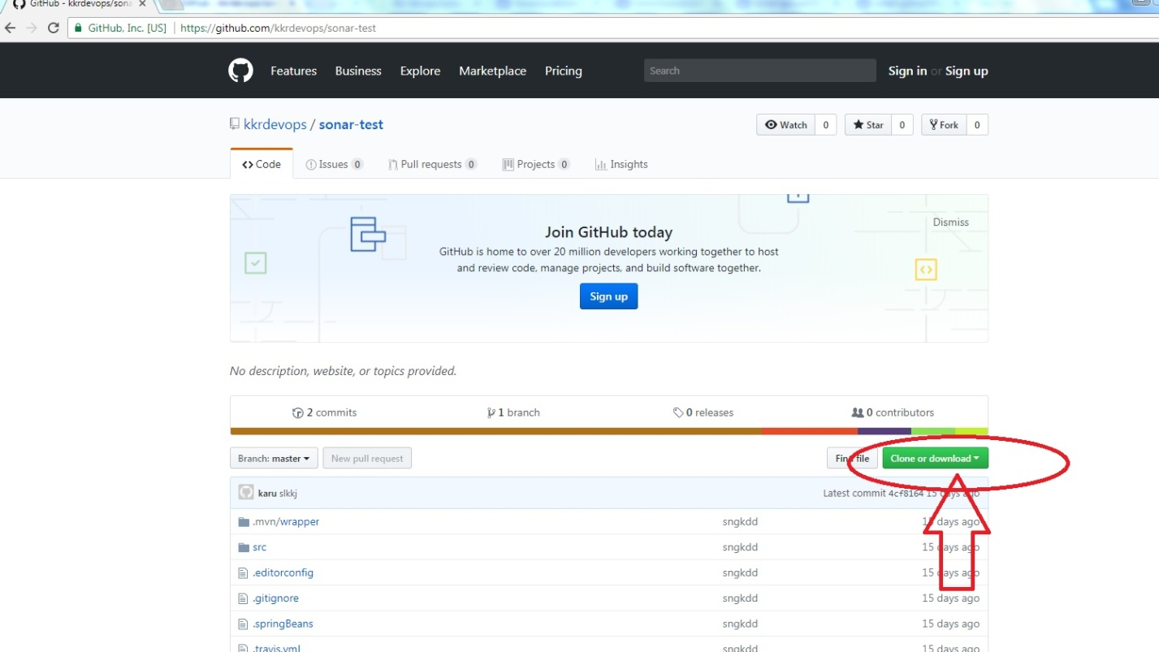

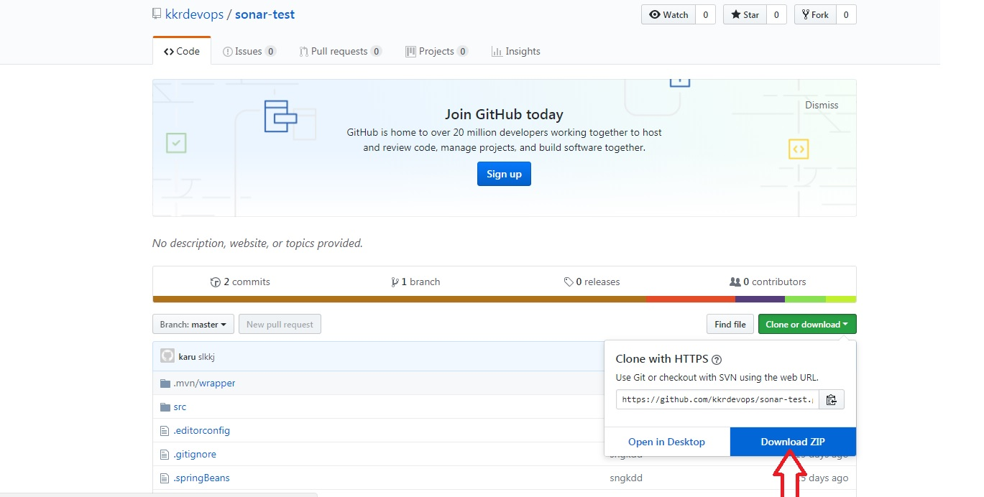

Step : click on Download ZIP



Step : extract the zip file

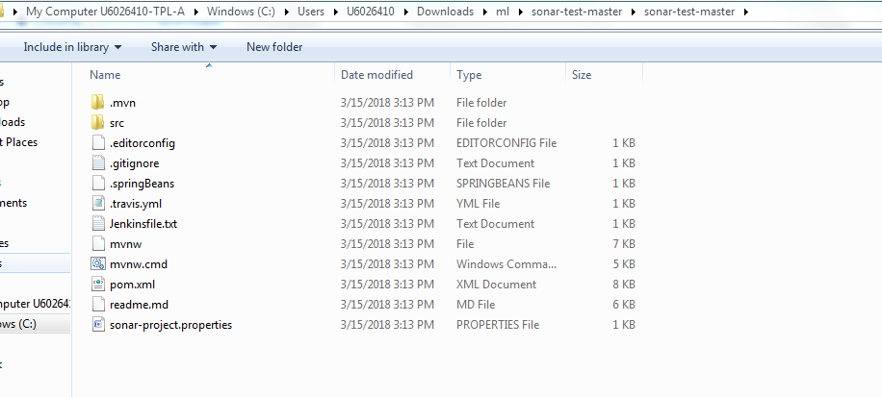

Step : copy the all files into sonarrunner folder path

Step :

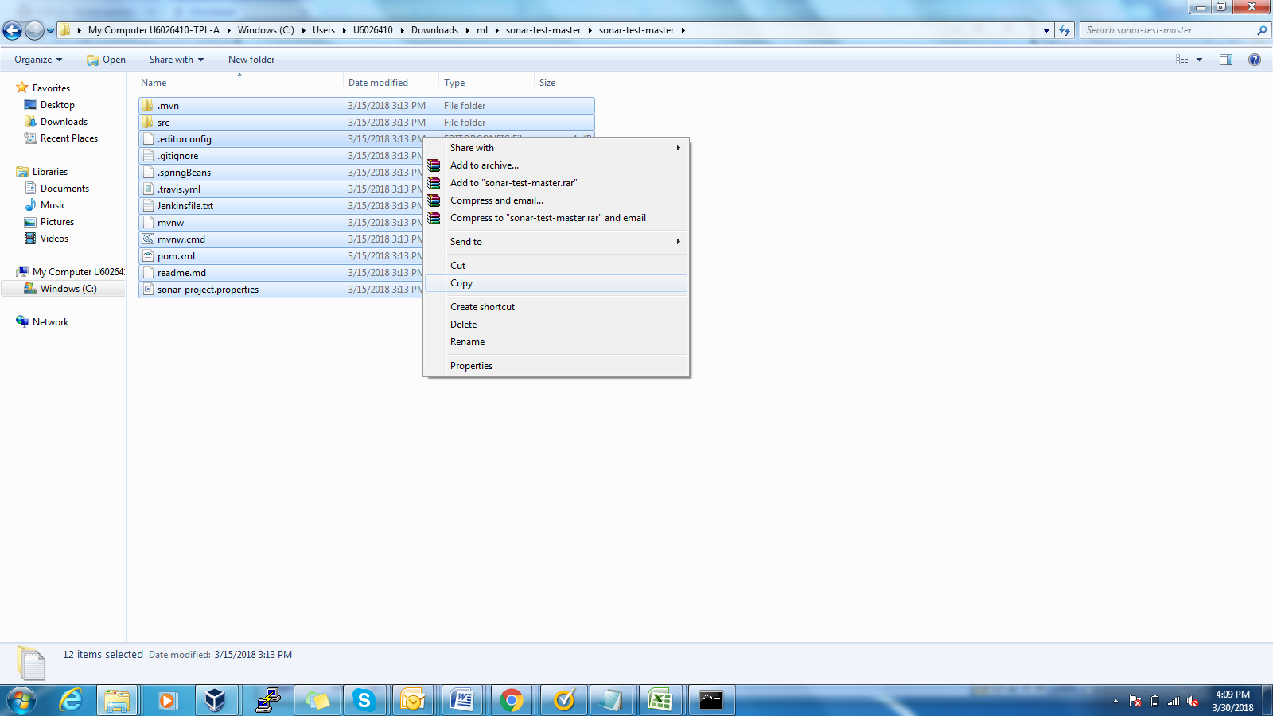

Step sonar runner path

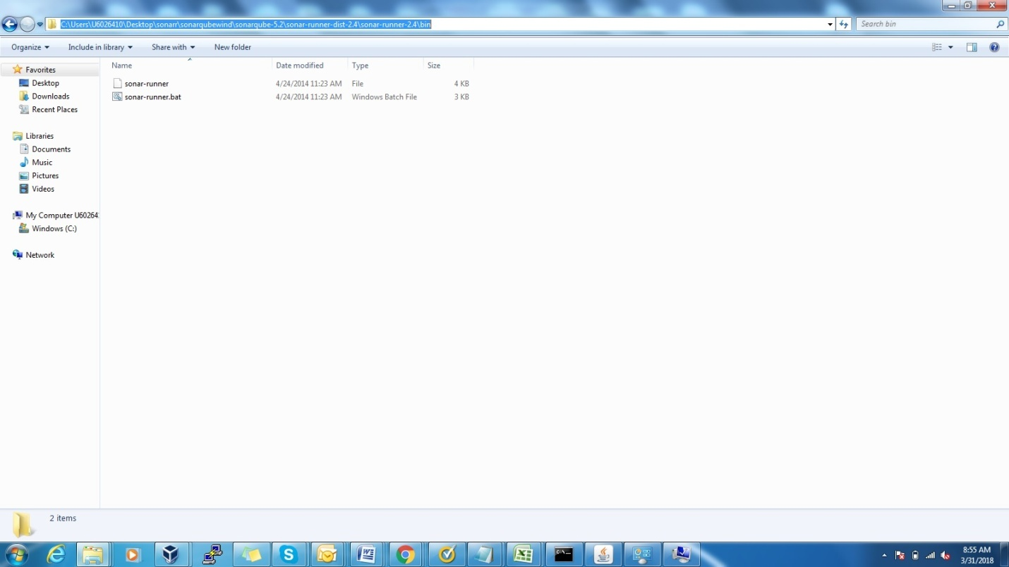

Step : Copy that maven code into the sonar runner bin folder,once you copy you will get below screenshot.

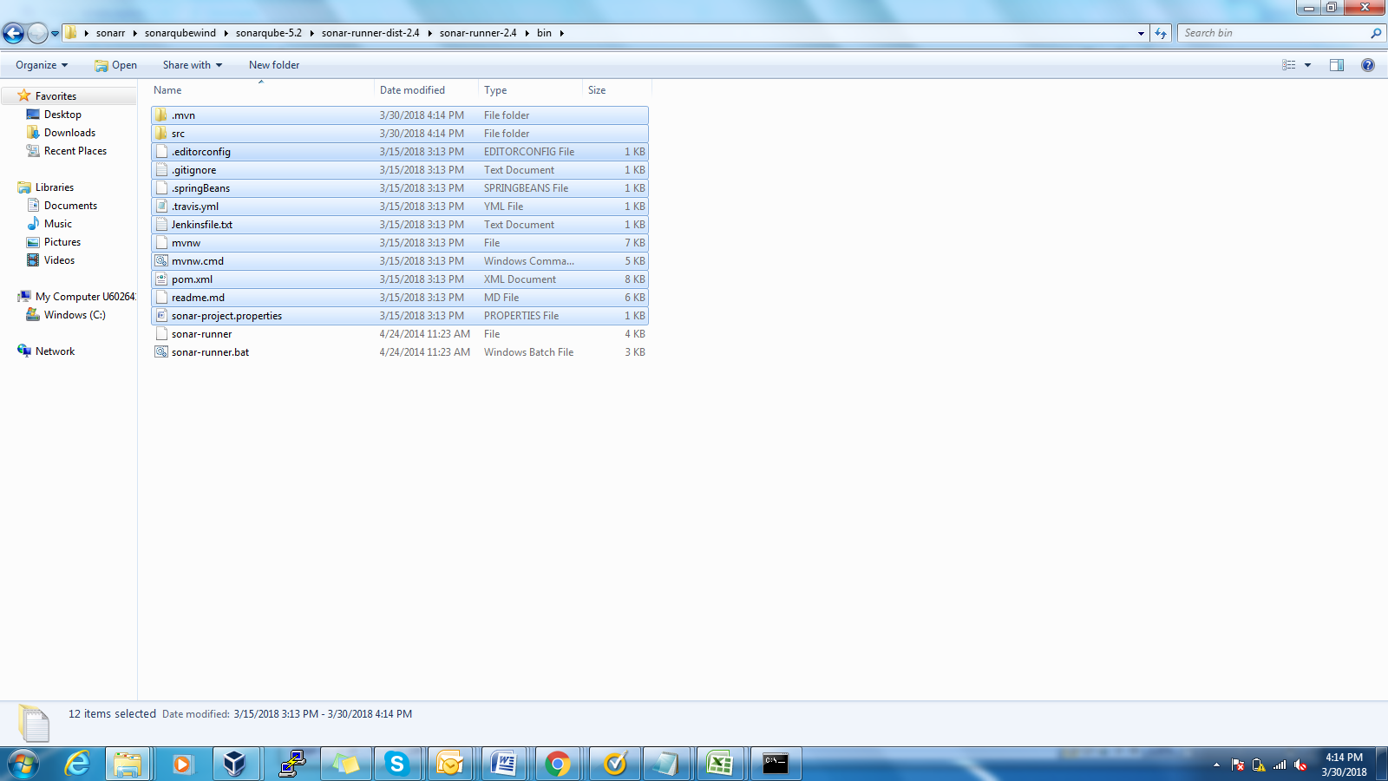

Step : Install Sonarqube plugin in Jenkins

Step : go to this link you will get sonarqube plugin: <https://updates.jenkins.io/download/plugins/sonar/>

Step :

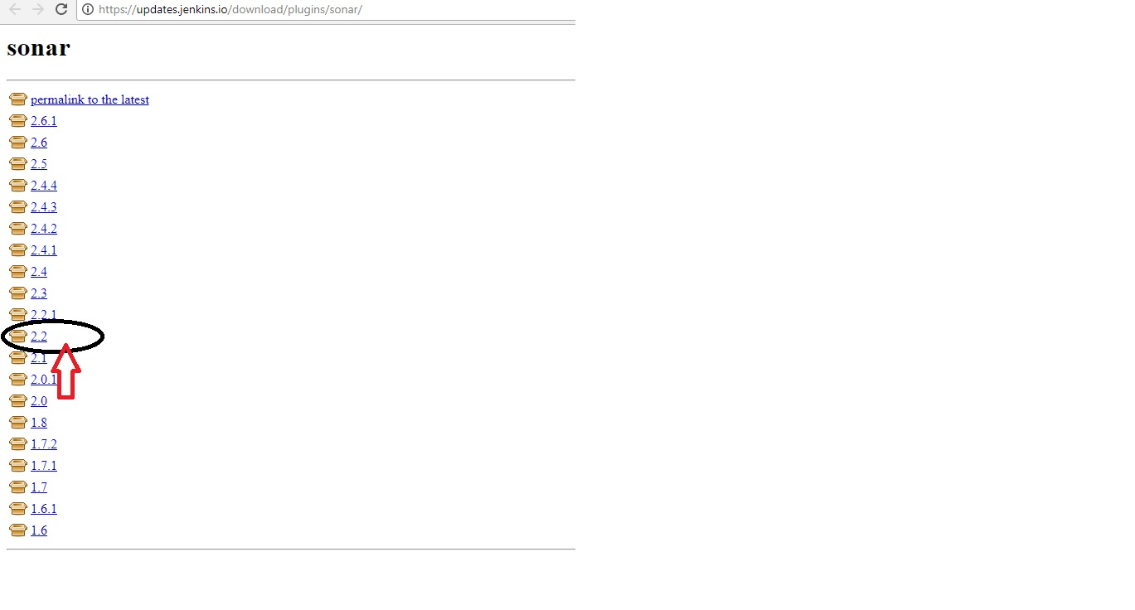

Step :

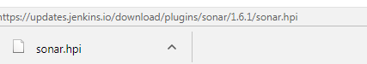

Step : Go to Jenkins🡪Manage Jenkins 🡪manage plugins🡪Advanced🡪select upload file option

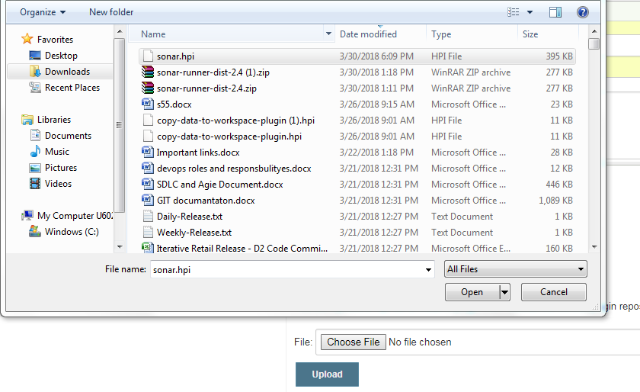

Step : checking sonarqube plugin version

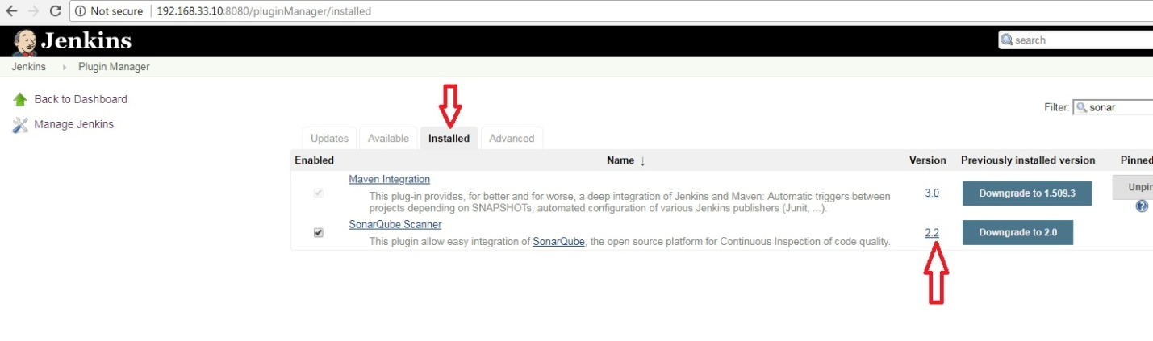

Step :click on Jenkins🡪manage Jenkins🡪Configure system🡪select SonarQube Runner option:

SonarQube runner name= SONAR_RUNNER

Sonar_Runner_Home = C:\Users\U6026410\Desktop\sonarr\sonar-runner\sonar-runner-dist-2.4\sonar-runner-2.4\ (as per your copy path)

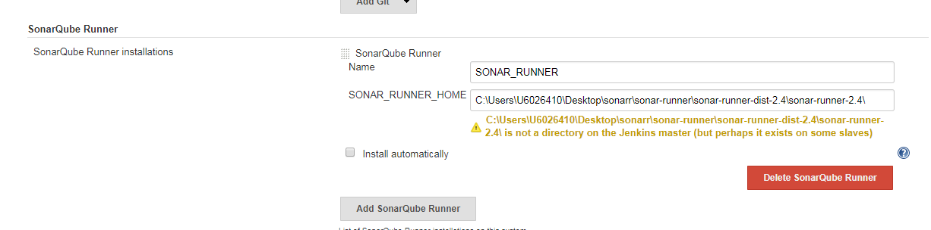

Step : Click on Jenkins🡪manage Jenkins🡪Configure system🡪click on SonarQube

Step : Configure SonarQube server installation path

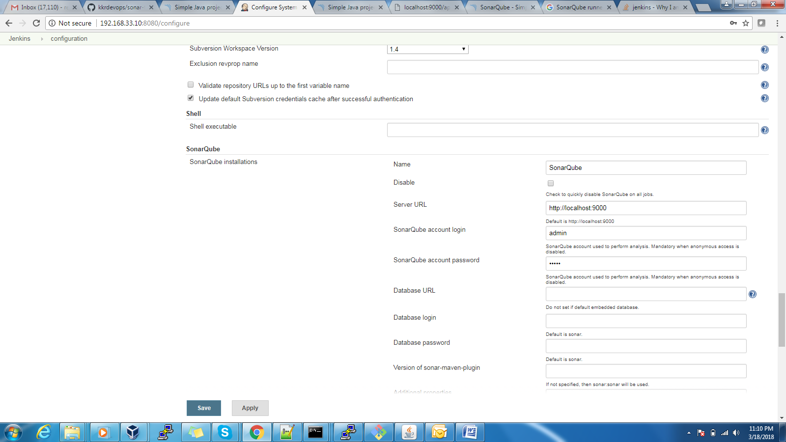

Create one Sonar Job in Jenkins:

Step :Click onNew Item🡪Iteam Name (Create CI_SonarQube_TEST)

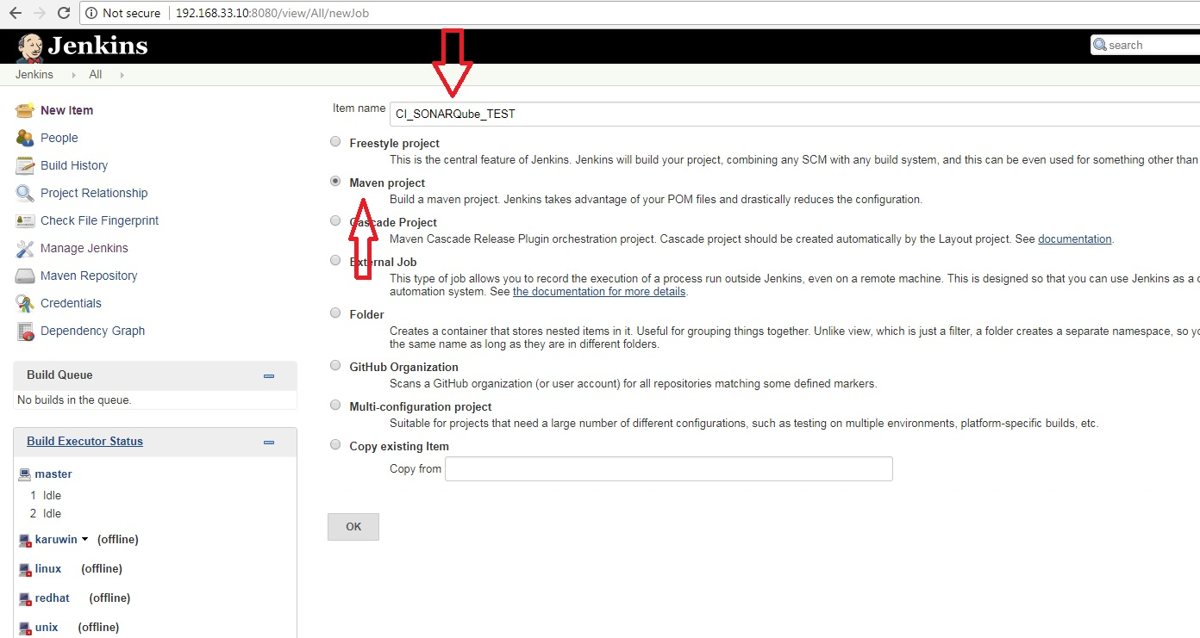

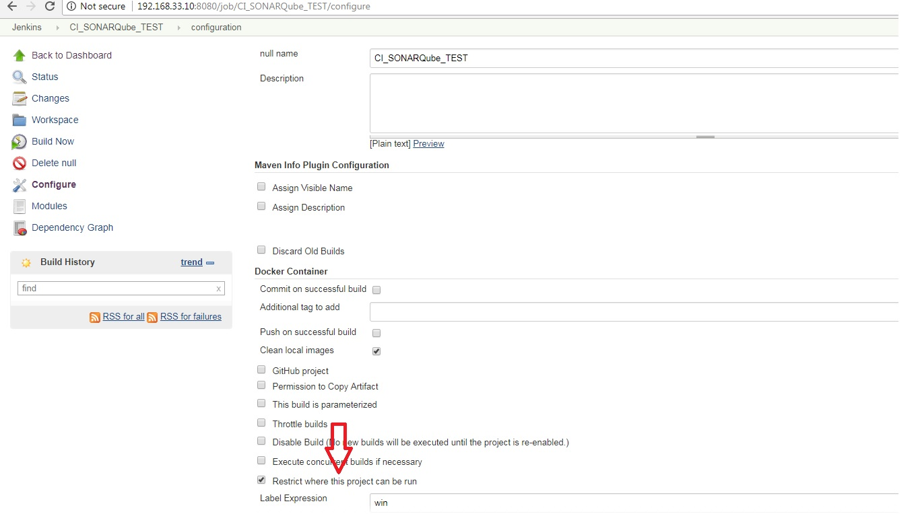

**Step1:** Give **Source Code Management—>Git repository URL**

**Step :** [**https://github.com/kkrdevops/sonar-test.git**](https://github.com/kkrdevops/sonar-test.git)

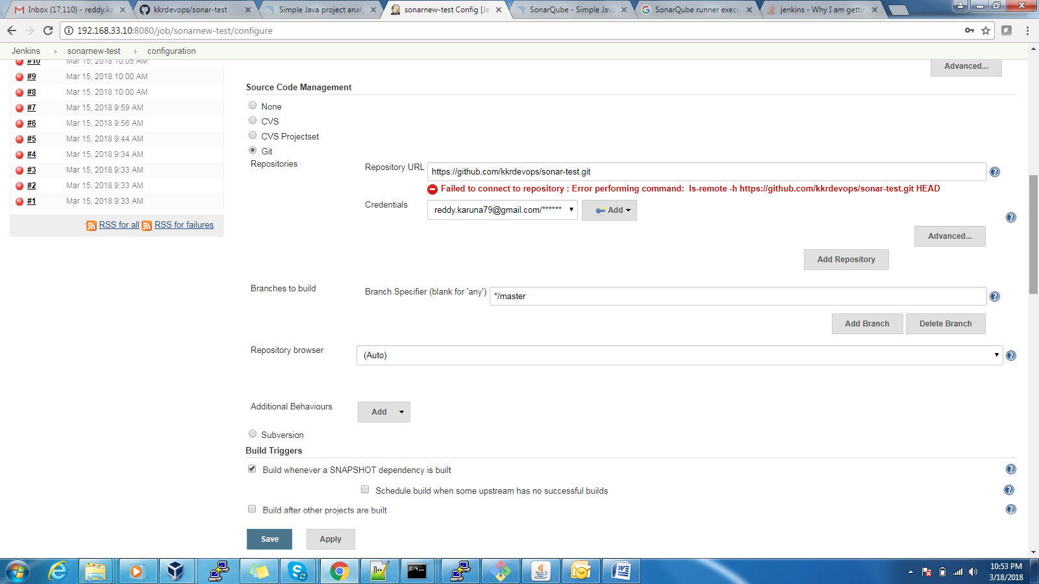

**Step : add post-build step 🡪Invoke Standlone SonarQube Analysis**

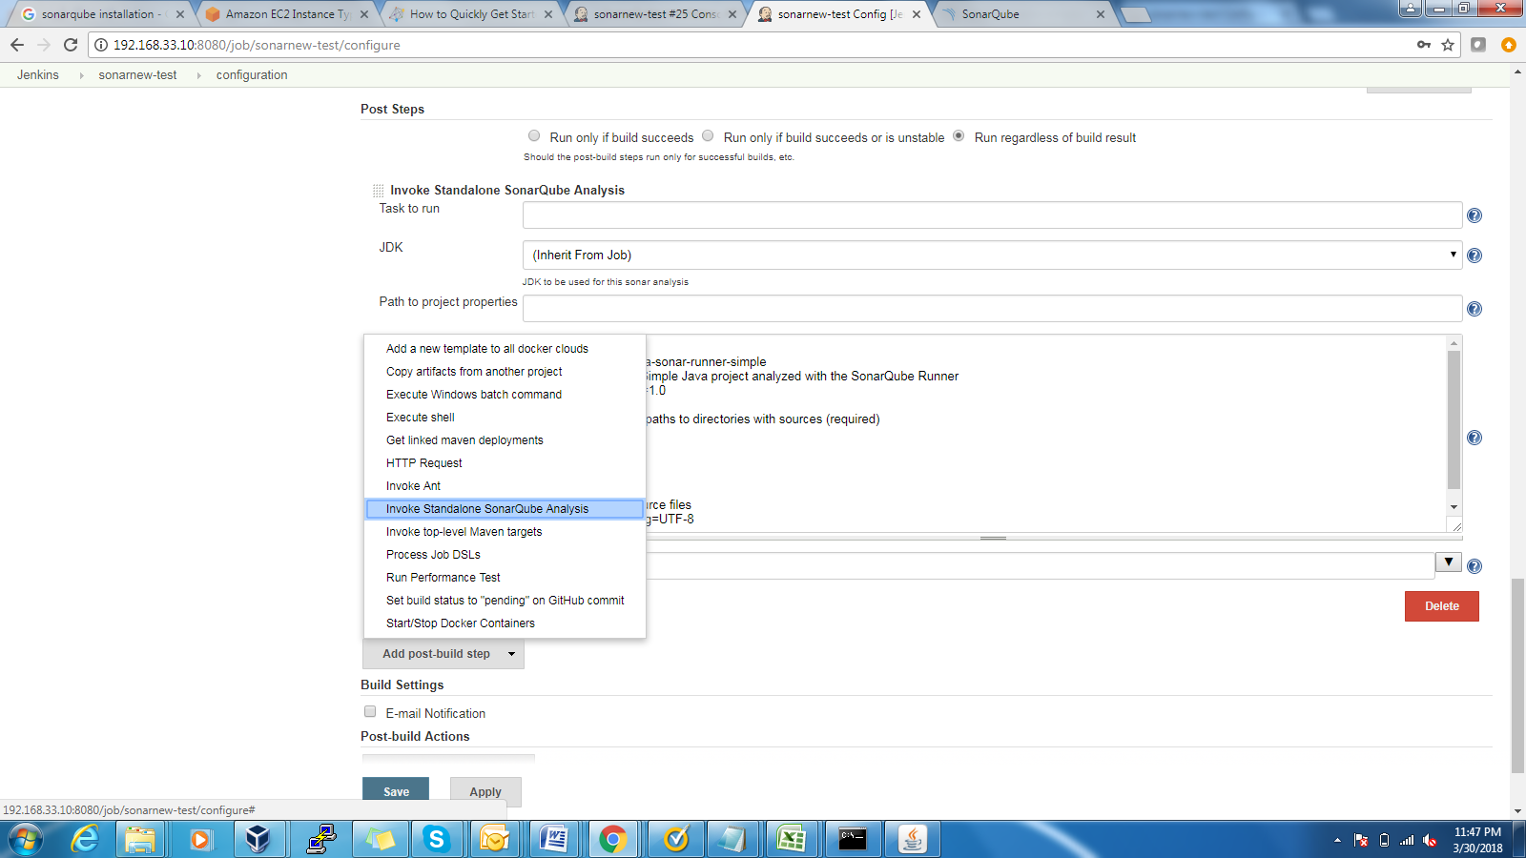

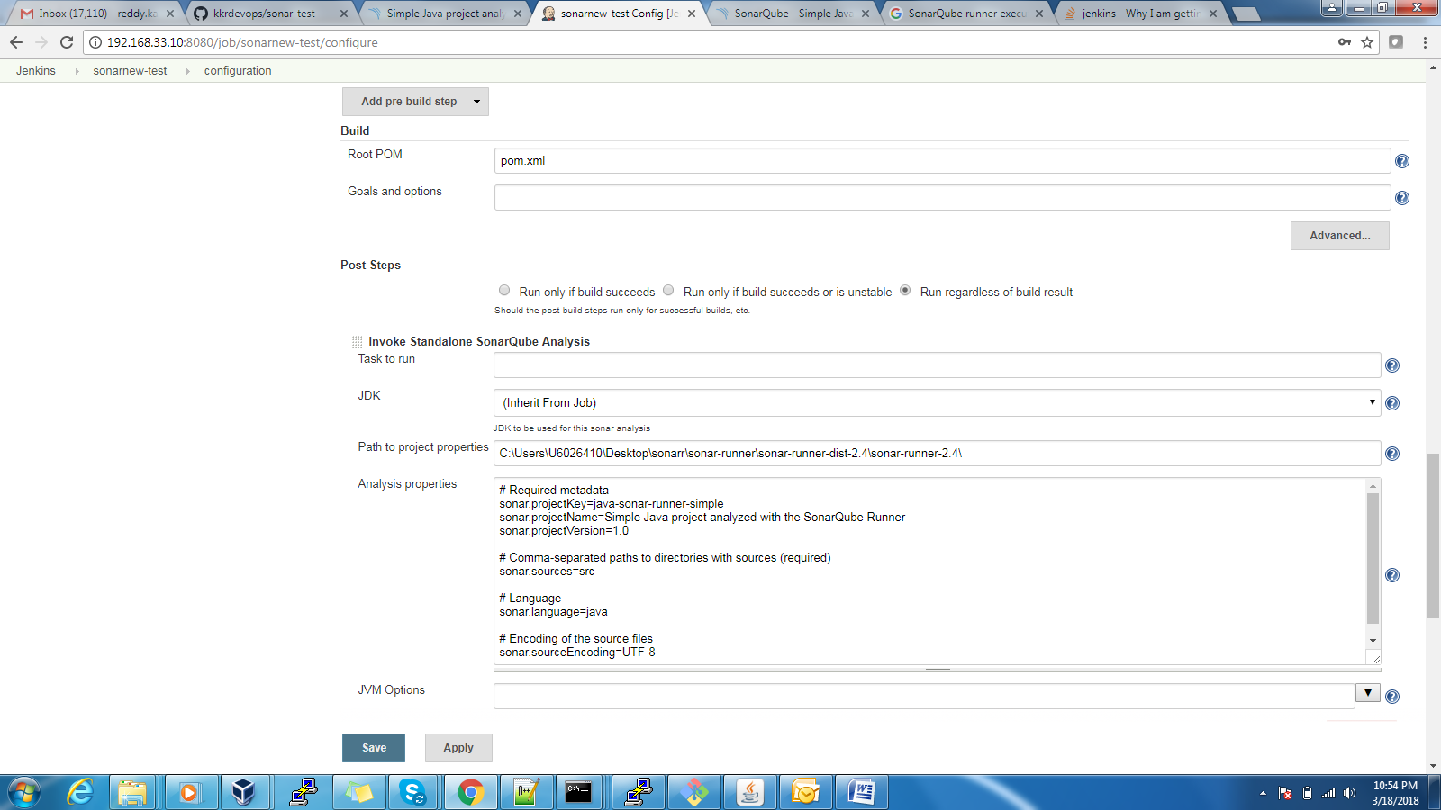

JDK – java_home

Analysis properties:

#Required metadata

sonar.projectKey=java-sonar-runner-simple

sonar.projectName=Simple Java project analyzed with SonarQube Runner

sonar.projectVersion=1.0

#Comma-separated paths to directories with sources (required)

sonar.sources=src

#Language

sonar.language=java

#Encoding of the source files

sonar.sourceEncoding=UTF-8

**Step :**

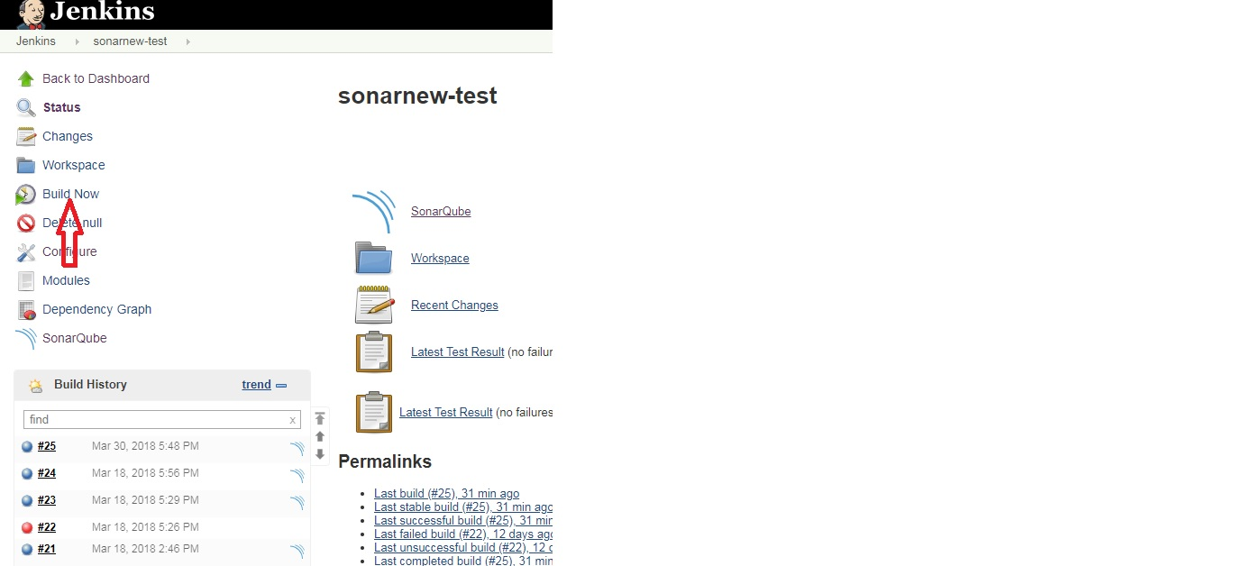

**Step : Click 🡪** [Console Output](http://192.168.33.10:8080/job/sonarnew-test/25/console)

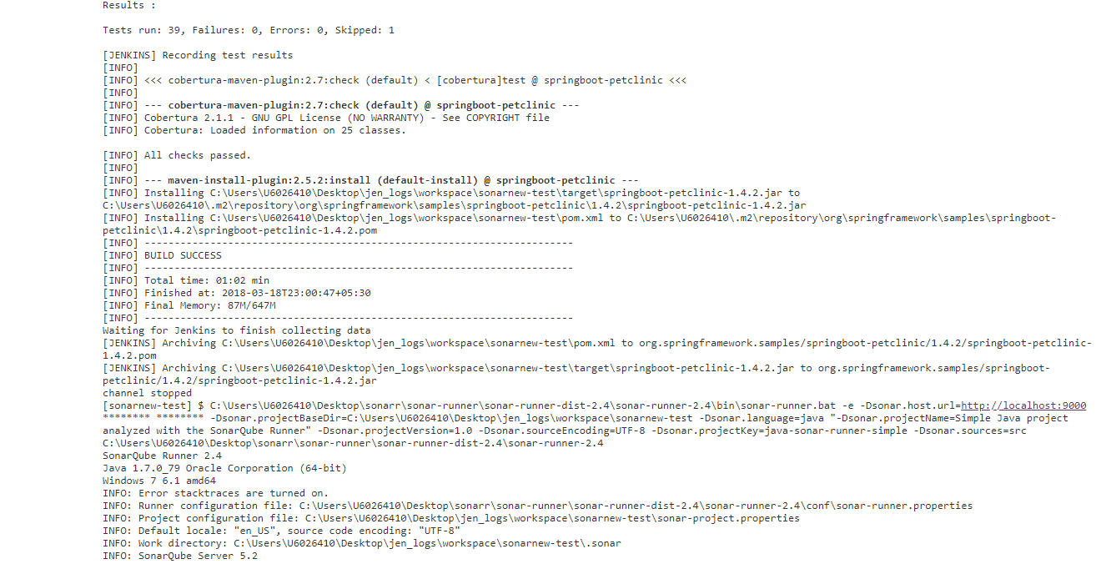

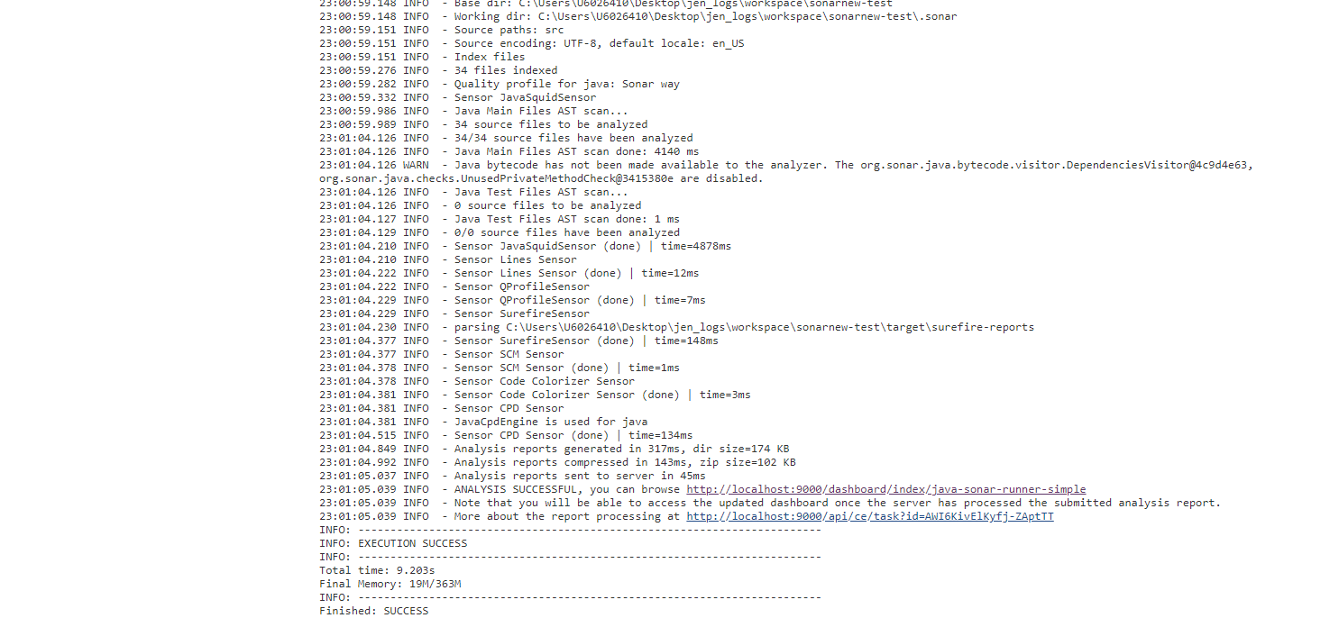

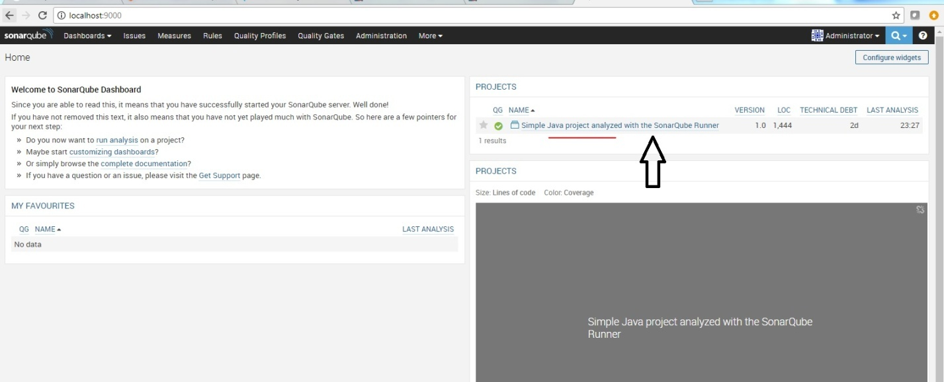

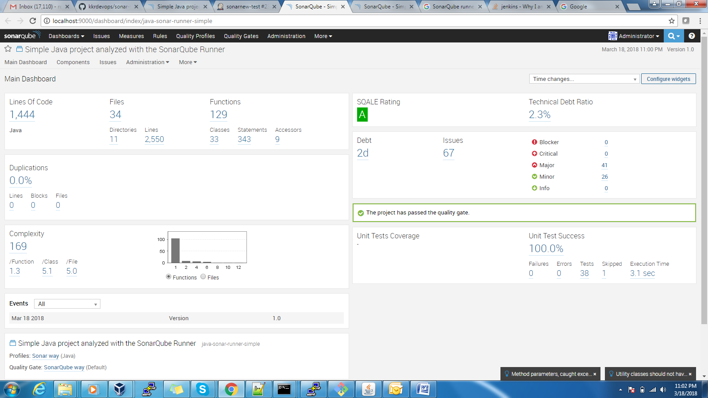

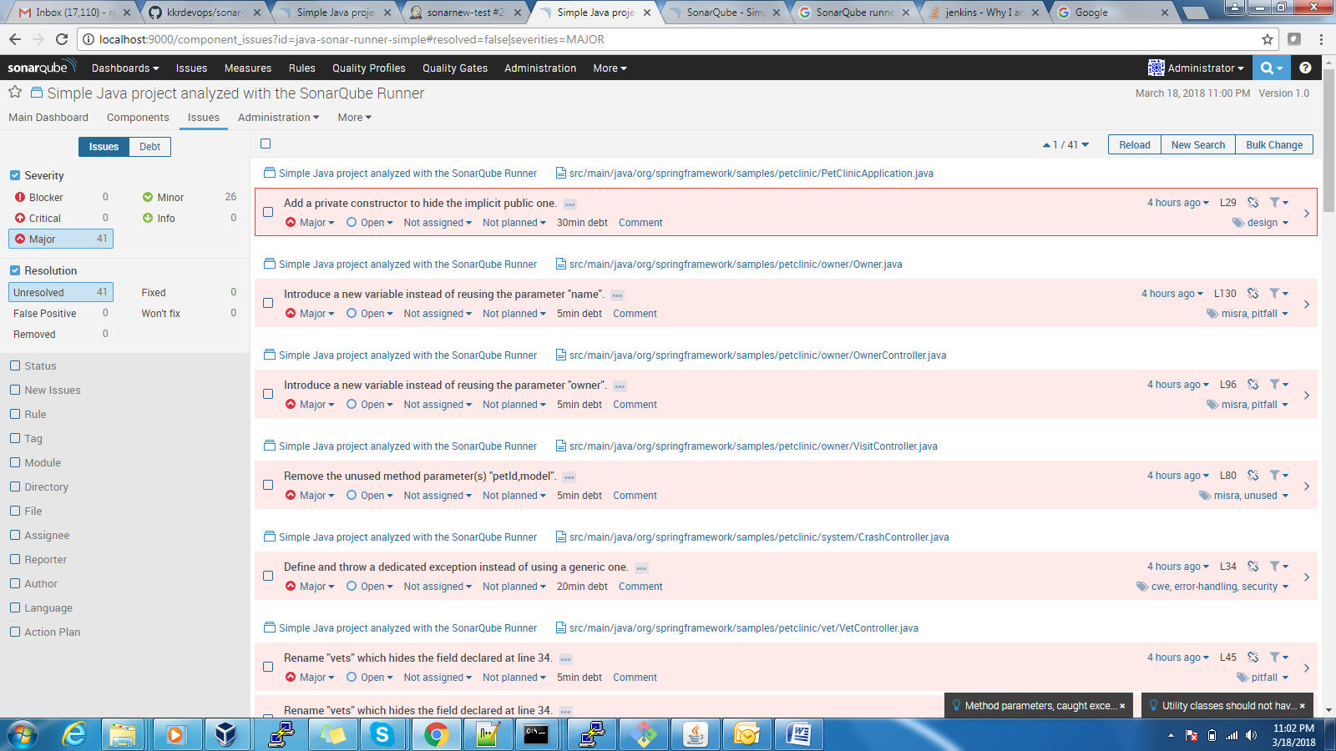

Step:

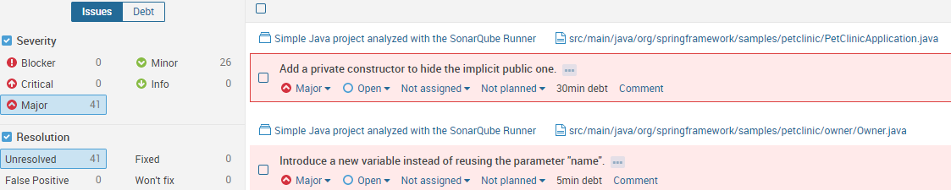

Step :

